|  |  |
| --- | --- |
| **EXP : 6** | **Write a Servlet to demonstrate  session tracking using HTTP Session.** |

**AIM:**

To Write a Servlet Program to demonstrate session tracking using HTTP Session.  
Implement a simple login system where the user's session is tracked.

**CODE:**

**Session.html:**

<!DOCTYPE html>

<html>

<head>

<meta charset="ISO-8859-1">

<title>Login</title>

</head>

<body>

<form action="/Pavithra/HttpSessionHandle" method="POST" style="margin-left: 50px">

      <p>

      <label>Username:</label><input type="text" name="username"/><br><br>

      </p>

      <p>

      <label>Password:</label><input type="password" name="password"/><br><br>

      </p>

      <p>

      <input type="submit" value="Login" style="margin-left: 130px"/>

      </p>

</form>

</body>

</html>

**HttpSessionHandle.java:**

package com.pavithra.servlet;

import java.io.IOException;

import java.io.PrintWriter;

import javax.servlet.ServletException;

import javax.servlet.annotation.WebServlet;

import javax.servlet.http.HttpServlet;

import javax.servlet.http.HttpServletRequest;

import javax.servlet.http.HttpServletResponse;

import javax.servlet.http.HttpSession;

/**

 * Servlet implementation class HttpSessionHandle

 */

@WebServlet("/HttpSessionHandle")

public class HttpSessionHandle extends HttpServlet {

private static final long serialVersionUID = 1L;

    /**

     * @see HttpServlet#HttpServlet()

     */

    public HttpSessionHandle() {

        super();

        // TODO Auto-generated constructor stub

    }

/**

* @see HttpServlet#doGet(HttpServletRequest request, HttpServletResponse response)

*/

protected void doGet(HttpServletRequest request, HttpServletResponse response) throws ServletException, IOException {

PrintWriter p = response.getWriter();

HttpSession session = request.getSession(false); // false = don't create if not exists

if (session != null && session.getAttribute("username") != null) {String user_name = (String) session.getAttribute("username");p.println("Username is " + user_name);

} else {

p.println("No active session. Please login.");

}

}

/**

* @see HttpServlet#doPost(HttpServletRequest request, HttpServletResponse response)

*/

protected void doPost(HttpServletRequest request, HttpServletResponse response) throws ServletException, IOException {

// TODO Auto-generated method stub

doGet(request, response);

}

}

**HttpSessionHandleDisplay.java:**

package com.pavithra.servlet;

import java.io.IOException;

import java.io.PrintWriter;

import javax.servlet.ServletException;

import javax.servlet.annotation.WebServlet;

import javax.servlet.http.HttpServlet;

import javax.servlet.http.HttpServletRequest;

import javax.servlet.http.HttpServletResponse;

import javax.servlet.http.HttpSession;

/**

 * Servlet implementation class HttpSessionHandleDisplay

 */

@WebServlet("/HttpSessionHandleDisplay")

public class HttpSessionHandleDisplay extends HttpServlet {

private static final long serialVersionUID = 1L;

    /**

     * @see HttpServlet#HttpServlet()

     */

    public HttpSessionHandleDisplay() {

        super();

    }

protected void doGet(HttpServletRequest request, HttpServletResponse response) throws ServletException, IOException {

// TODO Auto-generated method stub

}

/**

* @see HttpServlet#doPost(HttpServletRequest request, HttpServletResponse response)

*/

protected void doPost(HttpServletRequest request, HttpServletResponse response) throws ServletException, IOException {

String username = "WTMA";

String password = "WTMA";

PrintWriter p = response.getWriter();

String user = request.getParameter("username");

String pass = request.getParameter("password");

if (user.equals(username) && pass.equals(password)) {

HttpSession s = request.getSession(true);

s.setAttribute("username", user);

// Correct path for redirect

response.sendRedirect("HttpSessionHandleDisplay");

} else {

p.println("Login Failed");

}

}

}

**OUTPUT:**

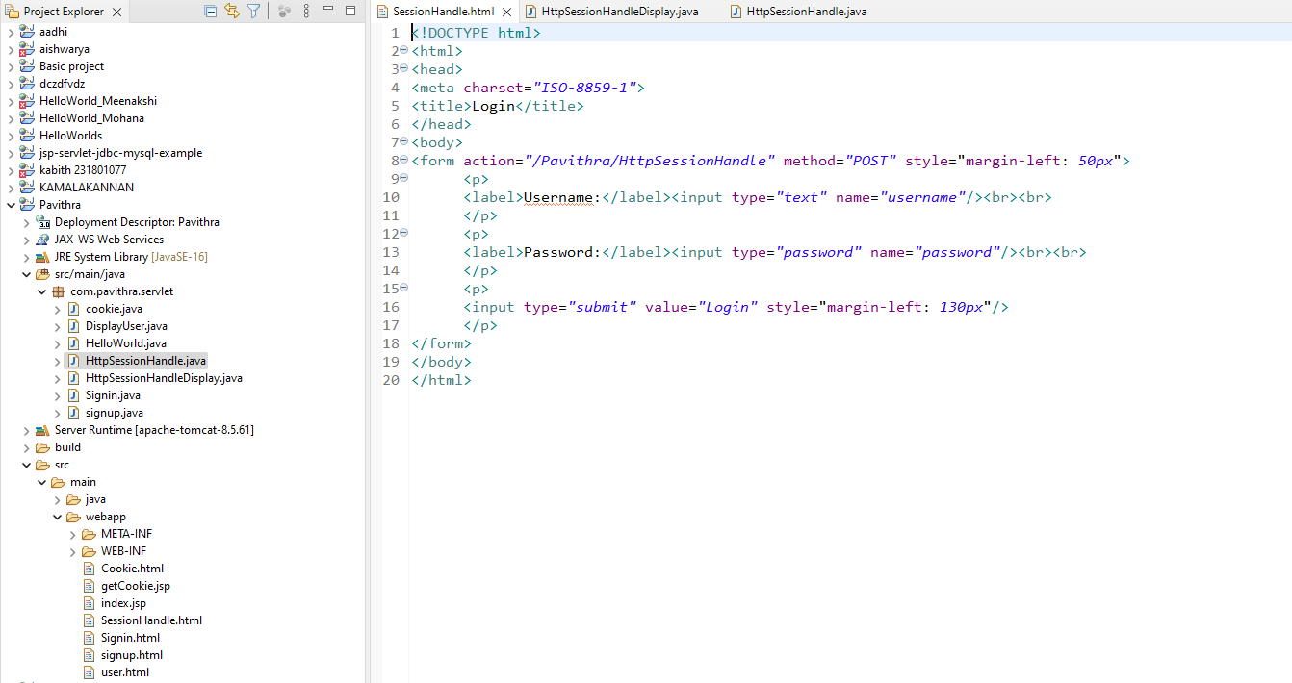

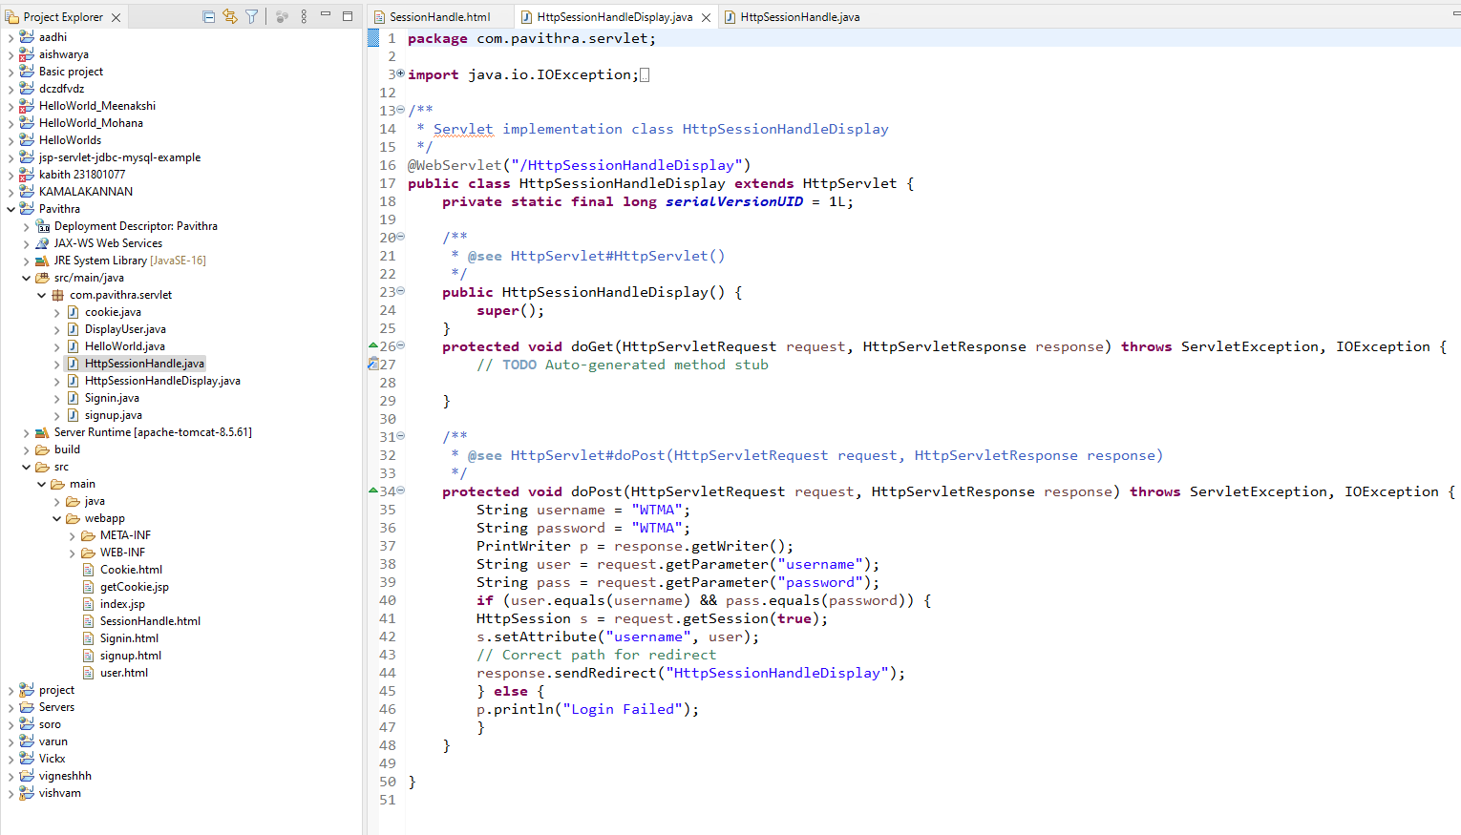

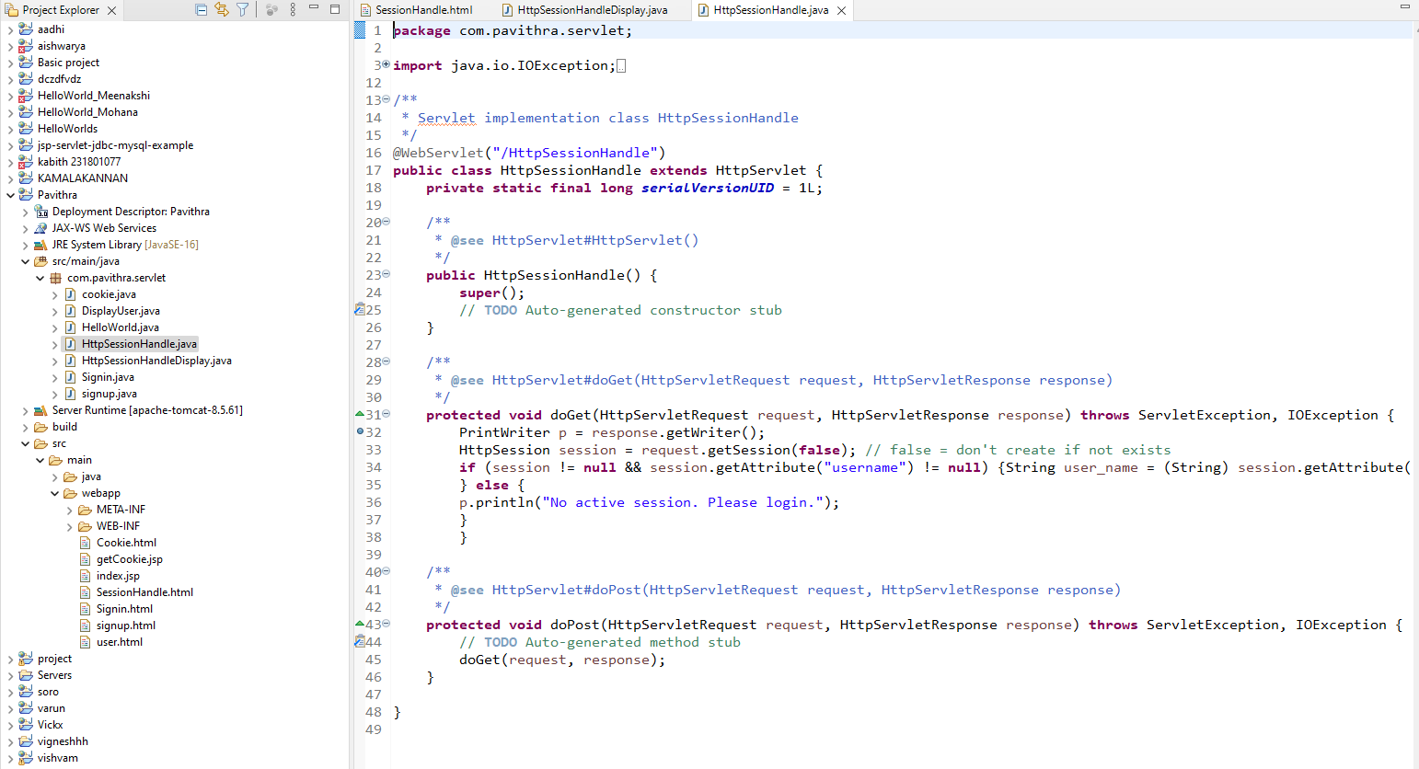

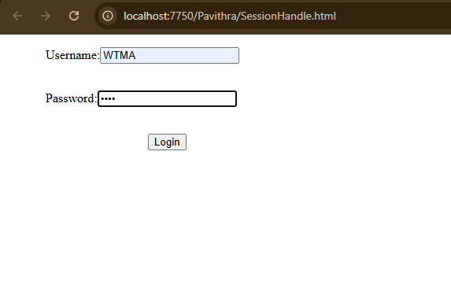

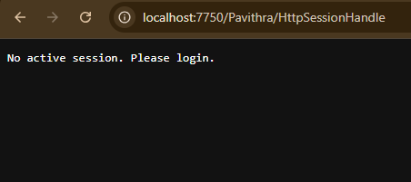

**RESULT:**

Servlet to demonstrate session tracking using HTTP Session Has been Executed Successfully.